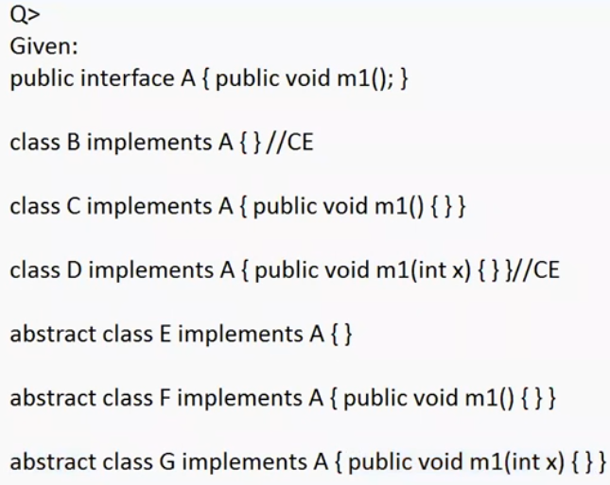

If the class implements interface and it doesn’t give the implementation for interface methods it must be marked as abstract. Otherwise it leads to compile time error.

To give the implementation to the interface method , method signature and return type should be same otherwise it leads to compile time error.

Eg: Inheritance_Eg14

Overridden method means based on the run time object the call will happen